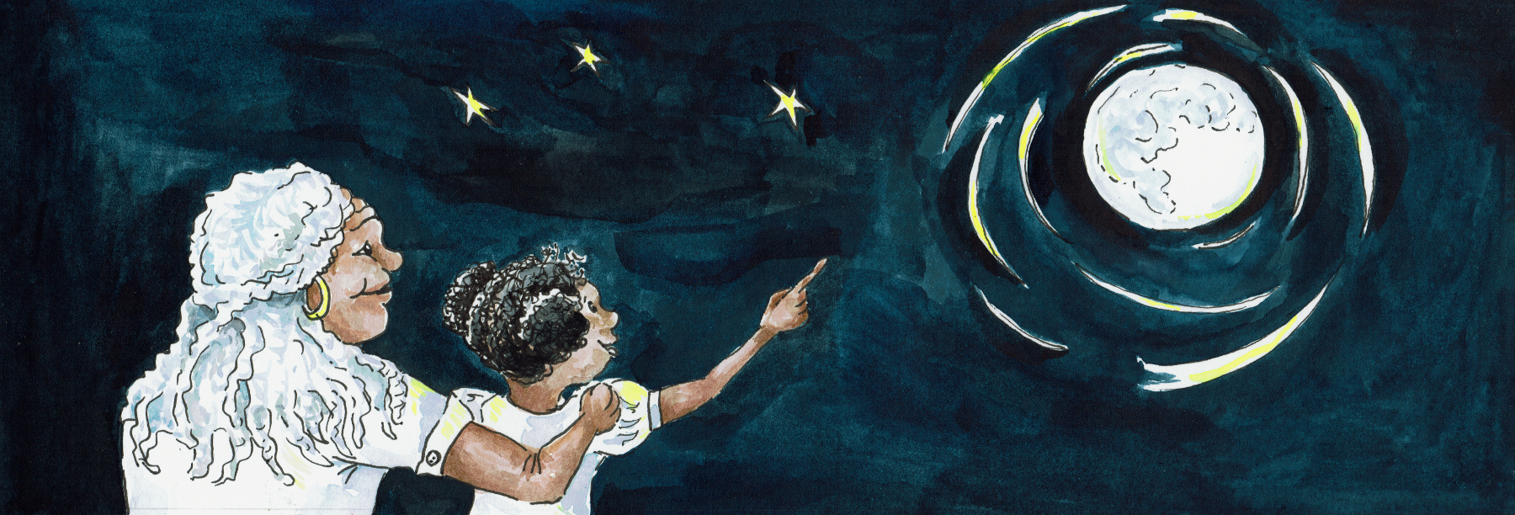
Suggested Age Range: 6 - 7 years: 7- 8 years; 8 - 9 years: 9- 10 years; 10- 11 years;
Suggested UK Year Group: Year Four, Year Five
UK Curriculum: Key Stage Two (Lower); Key Stage Two (Upper)
UK Curriculum Links: States of Matter; Earth and Space
Science Subject: Stars
Science Question: Is the Sun a Star?
Suggested Science Activity: Star Crowns; Solar System on a String
Children with SEND: Use with children to boost science vocabulary
EAL children: Intermediate Level
Country of Origin: First Nations of America
Source: The Star Husband by Lynn Moroney

Long ago, when the world was young, there was no Sun in the Sky and the world was always grey and cold. The animals got together to discuss what they could do to bring warmth and light to their world. They talked and they talked and they talked - but no-one came up with an idea until ….
“Ah-ah!” Said Coyote, the wild dog of the Prairie, “I have an idea!”
“What idea?” asked the animals
“Well” said Coyote “ One day, I was wandering along and wandering along. And I came to a Mountain…
“And?”
“I looked and I looked and I saw a crack in the side of the mountain!”
“And?”
“I peered and I peered into the crack and I saw something!”
“And?”
“I saw something dancing! It was orange and red and yellow and it moved up and down and around. It was so bright - and it was WARM!”
“What was it?”
“I think it was called Fire!”
“Take us there, so we can share the Fire?”
“I would - but I cannot remember where I saw it!” said Coyote sadly.
“Oh Coyote think, think hard!” the animals begged

And Coyote did! He thought and thought and thought.
“I cannot remember!” he said.
“Oh Coyote” sighed the Animals.”Maybe you could go and look for it again?"
“Yes I could! “said Coyote eagerly.
"And maybe some of us could go with you? To help you remember where it was and how to get there?” the Animals asked politely.
“Yes they could! They could! That would be a great idea!. We could bring the Fire back with us to share i with you all” said Coyote enthusiastically.

And so Hawk, Rabbit and Turtle volunteered to go with Coyote to find the Fire and bring it back to share with all the other animals.
But where was the Fire?
They looked and they looked and they looked - in all the low places, under the bushes and down into the ground - but the Fire wasn’t there.
Until at last they came to a lake.
By now - Turtle’s legs were beginning to ache.

“Maybe I could stay here by this nice and shady rock and rest for a while” he said.
And Coyote and Hawk and Rabbit left Turtle to rest.

And they looked and they looked and they looked - in all the high places, at the top of all the hills - but the Fire wasn’t there.
Until at last they came to the grass-lands.
And by now - Rabbit’s paws were beginning to ache.

“Maybe I could stay here by this nice juicy grass and rest for a while”
And Coyote and Hawk left Rabbit to rest.

They they looked and they looked and they looked - in all the narrow places, in between the rocks and crevasses - but the Fire wasn’t there.
Until at last they came to a forest .
And by now Hawk’s wings were beginning to ache.

“Maybe I could stay here by this tall tree and rest for a while”
And Coyote left Hawk to rest and carried on alone.

Until at last the forest ended. And there ahead of him was a Mountain.
And at the foot of the Mountain, there was a crack between the rocks.
And something orange and bright - shone out! The Fire! He had found it at last!

But …
In front of the crack in the Mountain stood Dragon-Fly!
“ Coyote what are you doing here?” he said.
“Oh” said Coyote “I have come to see the Fire”
“Well you cannot!” said Dragon-Fly.“Inside this mountain live the People and the Fire belongs to them. I am not letting you go into the Mountain Coyote! You might be tempted to steal it!”

“Who, me?” said Coyote. “Me steal the fire? I would not dream of it! I just want to dance with the Fire. If you will not let me in, I will just dance right here!”

And Coyote began to dance. He leapt up and crouched down, and then he whirled and swirled himself around. And Dragon-Fly was fascinated. He moved closer and closer to the Dancing Coyote and found himself joining in with the dance. He flew high and he flew down, and then he whirled and swirled himself around …

And Coyote seized his chance! Whilst Dragon-Fly was busy twirling around - he wasn’t guarding the entrance to the Fire! Coyote hurled himself past him and into the crack of the mountain! He found himself in a long, low tunnel, that led further and further into the Mountain. Ahead of him he could see this bright orange glow! And he began to run!
As he got closer and closer, it got brighter and brighter and bigger and bigger and until at last Coyote fell into a huge cave, with a ceiling far far above him.
And in the centre of the cave was the dancing, leaping, twisting, swirling Fire!

“Coyote!” thundered a voice. “What are you doing here?”
He looked around and there stood some the first people, glaring at him
"Oh, I just came to look at the Fire” he said.
“Really? Is that true? You came to look? Are you sure, you are not planning to steal it?”
“ Who me? said Coyote “Steal the Fire? I would not dream of it! I just wanted to dance with Fire. It is so beautiful! Please just let me show you how I can dance!”

And Coyote began to dance like the Fire. He leapt up and crouched down, and then he whirled and swirled himself around. And the People were so fascinated by his dance they found themselves drawing closer and closer and joining in with the dance! And as they whirled and swirled themselves around ….

Coyote seized his chance! He flicked his tail, grabbed a branch of fire, curled his tail around it and ran, running like the wind down the tunnel! And the People chased after him. Out of the tunnel and through the trees. In and out of the trees, Coyote ran, with the people chasing after him. Until at last he came to the tree where Hawk was snoozing.
“Hawk!”shouted Coyote “Catch the Fire!”

And Hawk woke up, saw the burning branch coming towards him. He swooped down and grabbed the branch in his beak and was off, flying across the grasslands with the people chasing after him. Until at last he came to where Rabbit was nibbling.

“Rabbit! “ shouted Hawk “Catch the Fire!”

And Rabbit saw the burning branch flying towards him! He jumped, grabbed the branch between his two front paws and ran as fast as he could towards the lake, with the people chasing after him. He ran and ran and ran, until at last he saw the rock where Turtle was resting.

“Turtle!” He shouted "Catch the Fire!”

And Turtle popped out his head from his shell, saw the Fire heading towards him!
He grabbed the Fire between his two tiny jaws and began to walk as fast as he could.

But….
Turtles are small and their legs are small. They cannot walk very fast at all!
And so it was so easy for the People to catch up with him!

But …
When Turtle saw a hand reaching out to grab the fire - he popped his head back inside the shell, with the Fire safe within his jaws! A hand picked up the Turtle by the shell and shook him.

“Give us back the Fire!” “No!” said a muffled voice inside the shell
“Give us back the Fire!” “Never!” Said a muffled voice inside the shell
“Give us back the Fire!” “No. Never. Not even if you threatened to throw me into the lake!” said a muffled voice inside the shell
“Turtle - if you don’t give us back the Fire - we WILL throw you into the lake!"
“Shan’t” said Turtle
And so, the People were so cross with Turtle - they threw him into the lake!
Which was of course exactly what he had planned! For Turtles can swim. And out of his shell, popped four little legs that swam and swam and swam. Until Turtle reached the other side of the lake.
Where all the animals were waiting! As Turtle staggered out of the water, Rabbit began to nibble blades of grass into tiny pieces. Hawk carried the pieces to Coyote, who gathered them up into a pile.Turtle placed the branch of fire on the grass and the grass began to burn!The other animals joined in. Bear brought bigger sticks and eagle brought more.
The fire grew higher and higher. And this gave Coyote one final idea.
He turned to Hawk and said: “Shall we put Fire in the Sky to bring light and warmth to everyone?”
And Hawk said “Yes!”
And so, Coyote rolled the fire into a great big ball, which Hawk carried up and up and up into the Sky. And there he left the burning ball - which we now call the Sun,
To bring light and warmth to everyone!
But is this story true?
Scientist say that the Sun, is actually a Star and is made of Gas …
But do YOU think that is true?

